This workforce solution was funded by a grant awarded under Workforce
Innovation in Regional Economic Development (WIRED) as implemented by the
U.S. Department of Labor’s Employment and Training Administration. The
solution was created by the grantee and does not necessarily reflect the official
position of the U.S. Department of Labor. The Department of Labor makes no
guarantees, warranties, or assurances of any kind, express or implied, with respect
to such information, including any information on linked sites and including, but
not limited to, accuracy of the information or its completeness, timeliness,
usefulness, adequacy, continued availability, or ownership. This solution is
copyrighted by the institution that created it. Internal use by an organization
and/or personal use by an individual for non-commercial purposes is permissible.
All other uses require the prior authorization of the copyright owner.
CALIFORNIA INNOVATION CORRIDOR
SUPPLIER TRANSFORMATION ANNUAL FORUM
CO-HOSTED BY BOEING SATELLITE SYSTEMS
OCTOBER 7, 2009

Supplier Innovations!



Boeing Satellite Systems, Event Center S24 E
2020 E Imperial Highway, El Segundo CA 90245
Agenda

7:30 am - 8:30 am Registration, Networking, Coffee
8:30 am - 8:35 am Welcome, California Space Authority (CSA)
Judy Turner, Director, Programs and Partnerships, CSA






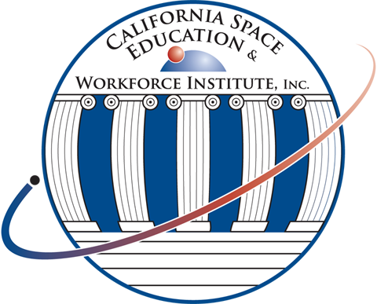
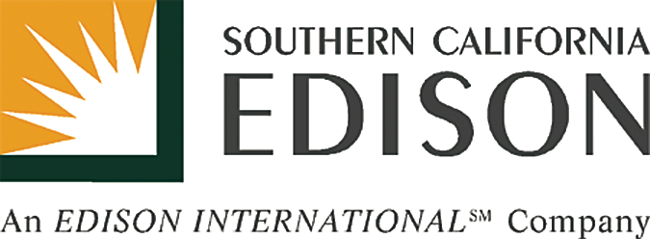
8:35 am – 8:50 am Executive Welcome, Boeing Satellite Systems
Stephen O’Neill, President, Boeing Satellite Systems, International; Vice President, Boeing S&IS
Commercial/Civil Satellite Programs
Tom Thrailkill, Director, Supplier Management & Procurement, Boeing Space and Intelligence Systems
8:50 am – 8:55 am Forum Agenda Objectives
Christine Purcell, Associate Director, Supplier Network, Industry Workforce and Manufacturing Development, CSA
8:55 am – 9:00 am Introduction of Keynote Speaker
9:00 am – 9:20 am Keynote Address, Manufacturing 2.0 - The Milken Institute Study
Jack Stewart, President, California Manufacturers and Technology Association
9:20 am – 9:40 am Legislative Update from Capitol Hill and Sacramento:
Stimulus Discussion
California Update, Jack Stewart, President, California Manufacturers and Technology Association




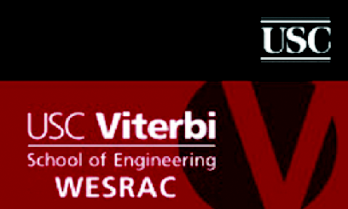






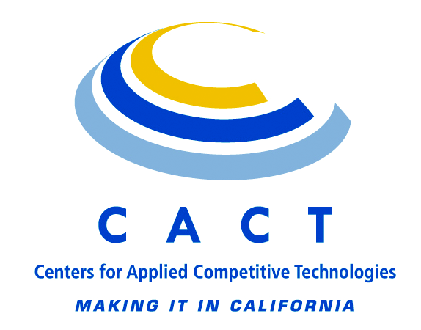
AB 32 – California Global Warming Solutions Act of 2006 Status and Implications, Ray Wells, Associate Director, Technology Commercialization and Business Development, CSA
Federal Update, Janice Dunn, Deputy Director, General Counsel and Federal Government Relations Director, CSA
Status of Federal R&D Incentives, Randy Eickhoff, President, Acena Consulting, LLC
9:40 am – 11:10 am Industry Requirements and Business Outlook - Panel and Audience Discussion
Jim Shultz, Director, Quality and Supplier Quality, Boeing Satellite Systems
Michael Gross, VP Subcontracts, Aerospace Systems, Northrop Grumman Corporation
Daniella A. Picciotti ASQ CQE, CMQ/OE, Senior Manager, Supplier Quality, Supply Chain Management,
Space & Airborne Systems, Raytheon
Gary Bartmann, Vice President of Procurement, Lockheed Martin Company
Peggy Berry, Director, Supplier Management, C3 Networks Division, The Boeing Company
Rigo Medina, NASA JPL
Willard B. Strozier, Deputy Director of Small Business, LAAFB Space and Missile Systems Center
11:10 am – 11:40 am Networking Break – all participants are invited to bring product
and services literature
11:40 am – 1:00 pm Industry Realities: Challenges and Successes - Panel and Audience Discussion
• 21st Century Supplier Network Competitiveness
Christine Purcell, Associate Director, Supplier Network, Industry Workforce and Manufacturing
Development, CSA

WWW.INNOVATECALIFORNIA.NET

• High Performance Computing, Design for Manufacturability, Complex Supply Network Dynamics
Gary Johnson, VP, ACE Clearwater Enterprises
Ken Dozier, Executive Director, USC Engineering Technology Transfer Center (ETTC) and
Western Research Application Center (WESRAC)
Dr. Keith Moo-Young, Dean of Engineering, California State University, Los Angeles
• DoD Common Supplier Requirements – Space Quality Improvement Council (SQIC) and Space Suppliers Council (SSC) Update
Gary Schipper, Space Quality Improvement, The Aerospace Corporation
• Configuration Management for the World’s Largest Laser – Serial Tracking and Site Registration
Ed Krieger, Team Lead, Controls and Information Systems, National Ignition Facility, Lawrence Livermore National Laboratory, Department of Energy
Mike Smith, Director, Professional Services, Glovia International
1:00 pm – 3:00 pm Lunch, Networking, Boeing Satellite Systems Production Tour
Tour times are subject to change and to limited attendance; open to government, military, suppliers, students, resources and training providers only based on earliest registration date and availability. Progressive lunch
with suppliers, primes, government and resources networking.
3:00 pm – 4:45 pm Industry Success via Leveraged Resources: Innovative Opportunities and Implementations – Panel and Audience Discussion
• Cost Accounting, Finance and Contract Management for Government Contractors
Michael Tinsley, President, and Tom Hernandez, VP Western Region, NeoSystems Corp
• Risk Management, Decision Support and Analysis Innovation
Joe Zino, The Goyak Group
• Standards—What Is Important and What Is Changing – AS9100 Update
Sidney Vianna, Det Norske Veritas Certification, Incorporated
• RFID as Counterfeit Parts Mitigation
Robert J. Vermillion, Certified, ESD & Product Safety Engineer-iNARTE, RMV Technology Group, LLC
• Tax Incentives - Manufacturing and R&D
Randy Eickhoff, President, Acena Consulting, LLC
• Government Resources for Suppliers:
- Department of Commerce Resources for Suppliers - Manufacturing Extension Partnership
- Department of DoD Resources for Suppliers – Mentor-Protégé Program
- California Community College – Centers for Applied Competitive Technology (CACT)
Terry Weiner, Senior Consultant, California Manufacturing Technology Corporation
- Small Business Administration
Paul Smith, Orange County SBA
- Department of Labor Resources for Suppliers – Employment Training Panel (ETP),
A California State Agency Providing Funds for Job Training
Jason Sakamoto, Economic Development Analyst, California Employment Training Panel
4:45 pm - 5:00 pm Q&A, Discussion, Summary, Refreshments, Networking
Opportunity Drawing – Includes Resources For Suppliers
Winner Must Be Present
Supplier Event Feedback Survey: www.CaliforniaSpaceAuthority.org/Supplier-Event/
Career Readiness Certificate Survey: www.CaliforniaSpaceAuthority.org/CRC-Survey/
Career Readiness Certificate Survey: http://www.innovatecalifornia.net/SupplierCapabilitiesAssessment

Questions: Christine Purcell (cp@californiaspaceauthority.org), 310.283.7323
Attendees must be U.S. citizens or permanent legal residents and must bring U.S. government-issued photo identification or resident alien card.
Partial funding provided by the U.S. Department of Labor, Employment &Training Administration WIRED Initiative
Participants agree to grant the California Space Authority (CSA) permission to use any photographs of the event in any and all publications for Government and/or non-government purposes, including web site entries, without payment or any other consideration in perpetuity. I hereby waive the right to inspect or approve the finished product, including written or electronic copy. Participants waive any right to royalties or other compensation arising or related to the use of the photographs.
Personal Electronic Devices: Cameras, cell phones with cameras and laptops may not be brought onsite at BSS. Wireless internet service will not be available.
Parking: There will be BSS Shuttles to the Event Center from other BSS paring lots – confirmed registrants will be provide exact parking instructions.
CSA thanks all of the presenters and attendees for their participation. All sessions are for general informational purposes only and not meant to be
specific professional advice to individuals or organizations. Participation in this Forum does not indicate formal endorsement by either CSA or The Boeing Company.

